University of Rochester
Department of Electrical & Computer Engineering
ECE111 Lab #3 Resistive Network Trimming
Oct. 9 or 10, 2014
---------------------------------------------------------------------------------------------
Write-ups, prepared in the format described previously, are due one week after you have demonstrated your design to the TA. Include a typed Executive Summary with your write-up on a separate sheet. Your grade will be based upon (i) conciseness, grammar, and spelling of the Summary and (ii) completeness and correctness of the write-up. Late work is not accepted.
---------------------------------------------------------------------------------------------
I. Purpose of this exercise
To verify the principle of Superposition, that the output of a linear circuit due to multiple independent inputs is equal to the sum of the outputs due to each input taken separately, with all other inputs turned off.
II. Procedure

Take the voltage across the 100Ω resistor as the desired output. Predict this voltage by whatever method you prefer.
Build the circuit below in the lab on a breadboard, using the bench power supplies for the two voltage sources.
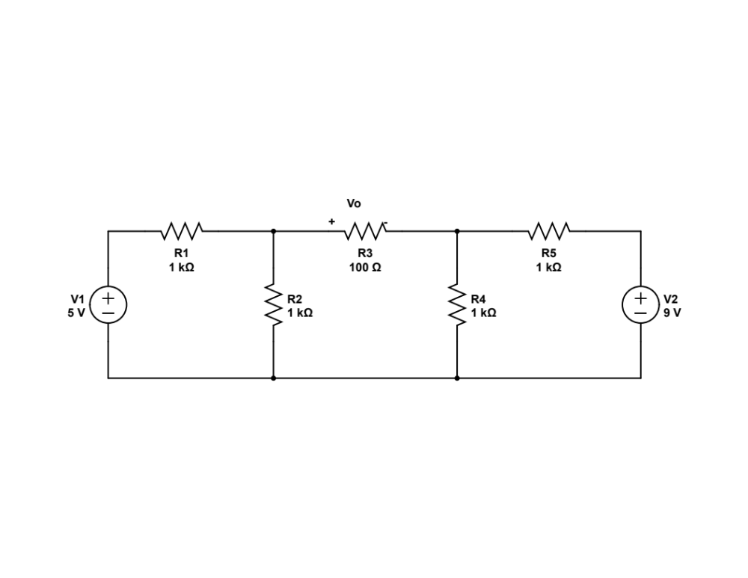
III. Procedure
- With both sources on, measure the output voltage, with the correct polarity.
- Turn off both voltage sources (BE CAREFUL TO TURN THEM OFF CORRECTLY, AS DESCRIBED IN CLASS ON 10/6.)
- Turn on the 5V source, and measure the output voltage, with the correct polarity, and call it Vo1. Turn that source back off. Calculate G1.
- Turn on the 9V source, measure the output voltage, call it Vo2. Turn that source back off. Calculate G2.
- Now, predict the output voltage if the 5V source is changed to be 9V. Change the setting on the power supply appropriately, turn both sources on, measure the output Vo and compare it to your predicted result.

